1st Chakra – Inspiration / Eleni Ntaga
- Μουσική
https://youtu.be/-6mYCjUrHtg?si=ANxkqPqMNbULHwff

Moves attention towards the body

- Body practice: Malasana

Helps letting go
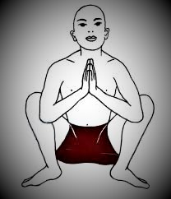

- Sound: footsteps
Our sound as two legged beings forms music, imagine listening to all footsteps of people walking right now on earth
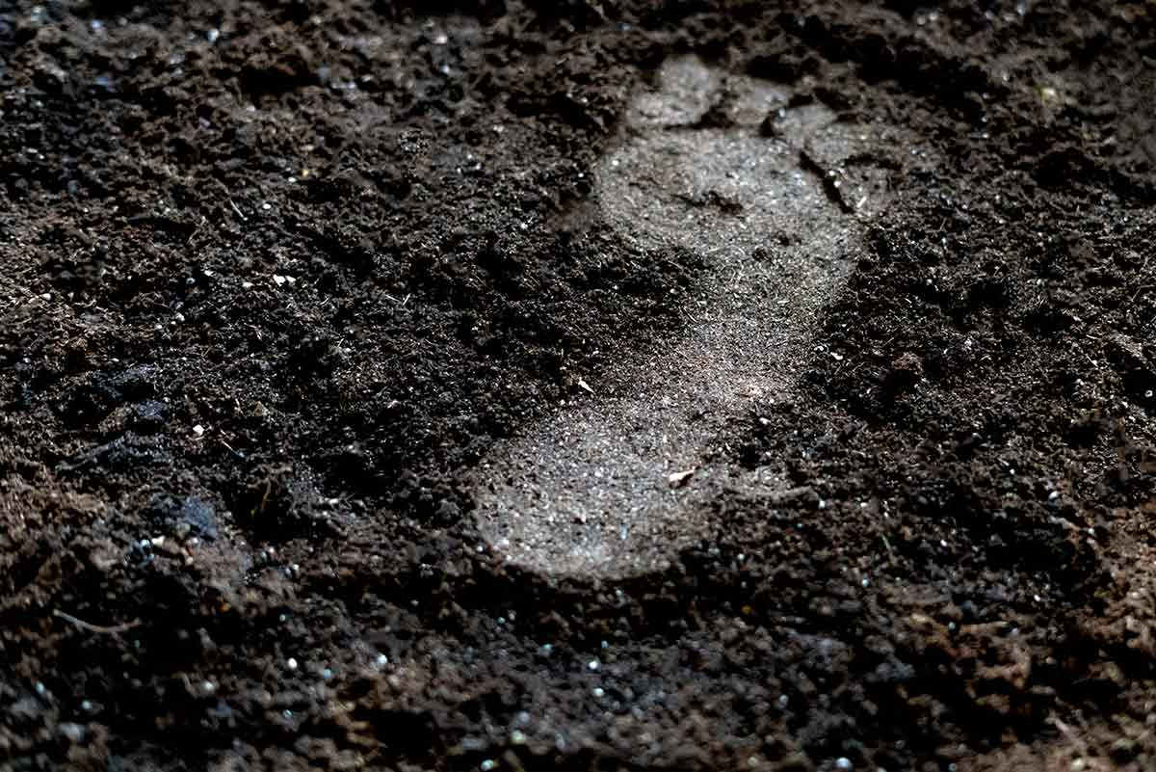
- Image: soil
What we all become

- Colour: black & red like lava
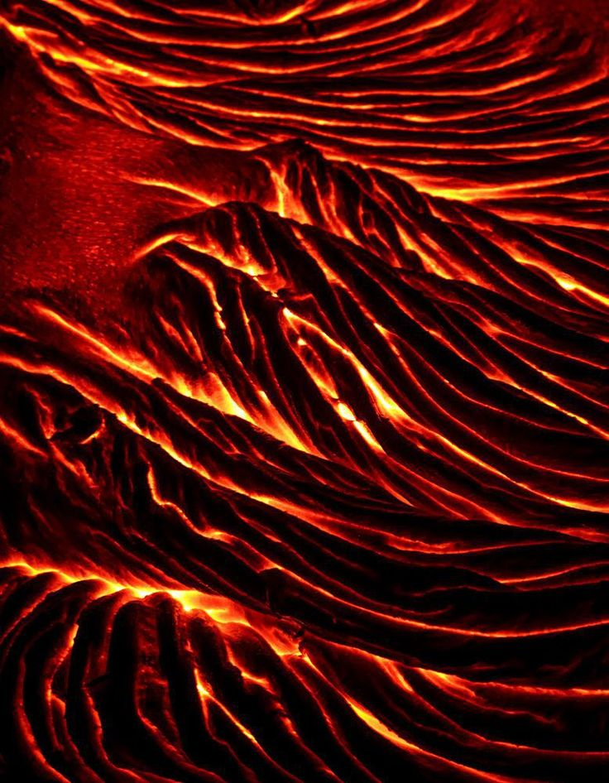

A different kind of core heart

- Taste: sweet

Dig in to earth to find your sweet tasted truth
comforting like the taste of beetroot or potatoe

- Dance: Aborigines of Australia
https://youtu.be/SedA7w8vy9g?si=Xop0UwCtsGIIS507

mud on the body, hit the ground with your feet and let the earth rise through you

